Question(s): https://www.mountvernon.org/george-washington/constitutional-convention/constitution-timeline#event-the-constitutional-convention-begins
- What year was the Constitution written?
- What year did the Constitution take effect?
- What year is it today? Can you figure out how many years the Constitution has been in effect?

We the People
The Constitution starts with three famous words: We the People. Given these words, who do you think has the power in our government? That’s right — WE do!
Back when the Constitution was written, this concept of self-government was pretty shocking. In those days, almost all countries were ruled by a king of some kind. People were used to their government telling them what to do, not the other way around.
The opening paragraph of the Constitution is called the Preamble. It explains what the writers were trying to do:
- Form a better union among the states
- Create a fair legal system
- Guarantee peace inside the country
- Join all the states together to defend against attacks
- Help support people’s well-being
- Make sure all future generations remain free
And how did they plan to accomplish all this? Well, they tell you in the very last line of the Preamble: by establishing the Constitution!
Follow the link to watch a famous music video that’s all about the Preamble! (Can you sing along?)

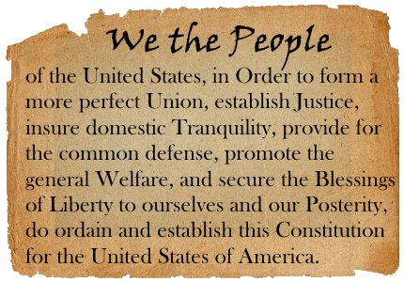

Webquest Link(s):
School House Rock -- The Preamble
Question(s):
Choose one of the goals listed in the Preamble. How do you think creating rules for a new government to follow could help meet that goal?

Separation of Powers
By now, you probably can’t wait to dive in and learn about the Constitution! Before you do, you should know this:
The Constitution was carefully designed to divide the powers of government and put them into different hands.
Why this “separation of powers”? Because the early Americans knew that too much power in one place can lead to all kinds of trouble—and even threaten people’s freedom!
Follow the link to read about separation of powers. Then, answer the questions below.

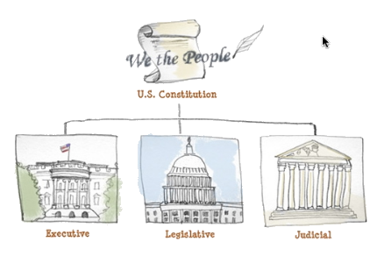

Webquest Link(s):
Separation of Powers
Question(s):
- What were the Framers afraid of?
- What did they create in order to prevent that?
- What do you think would happen if one group of people got to make laws, enforce them, decide what the laws mean, AND judge whether someone had broken a law?

Article I: The Legislative Branch
The Constitution is organized into different parts called Articles. There is one article for each branch of government—and a few extra articles that talk about other stuff.
Article I talks about the legislative branch of our government. The Constitution says more about this branch than it does about the other two. (Any ideas why?)
Follow the link, then follow the instructions in the questions to find out about Article I. (If you have trouble with roman numerals, you might want to keep this chart open: Roman Numerals Chart)

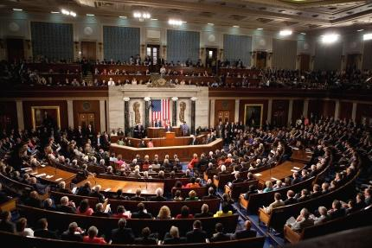

Webquest Link(s):
Guide to the Constitution
Question(s):
- How many sections does Article I have?
- Click on the link for Article I, Section 1. What two parts does Congress have?
- Click on the link for Section 2 and then Section 3. What is the main topic of Section 2? What is the main topic of Section 3?
- Click on the link for Section 8. What is listed in Section 8?
- Still in Section 8, scroll down to the part that says The Meaning. Who has all lawmaking powers not listed in Section 8?

Article II: The Executive Branch
Next, the Constitution explains the executive branch of our government.
Follow the link, then follow the instructions in the questions to find out about Article II.

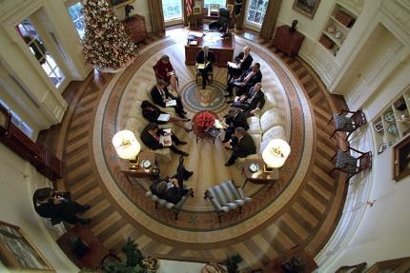

Webquest Link(s):
Guide to the Constitution
Question(s):
- How many sections does Article II have?
- Click on the link for Article II, Section 1. Who has the executive power?
- Click the link for Article II, Section 2. Find the part that says “The Meaning.” What does the president do as chief executive?
- Name two other things the president can do.

Article III: The Judicial Branch
Last but not least, it’s the judicial branch of government!
Follow the link and click on Article III, Section I. Find the part that says The Meaning.

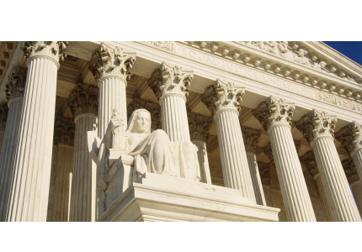

Webquest Link(s):
Guide to the Constitution
Question(s):
- What does Article III do?
- What major court did it create?
- What did it give Congress the power to do?

Article IV: States Playing Nice
In the early days, states often got along like quarreling brothers and sisters. They didn’t always play nice! That’s why Article IV talks about the way states are supposed to treat each other.
Follow the link, then follow the instructions in the questions.

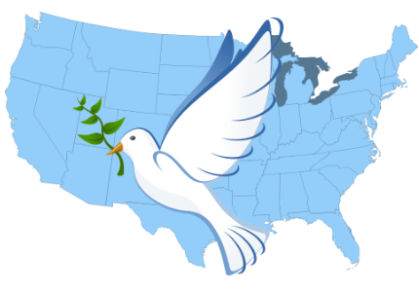

Webquest Link(s):
Guide to the Constitution
Question(s):
- Click the link for Article IV, Section 1. Find the part that says The Meaning. What does Section 1 require states to do?
- Click the link for Article IV, Section 2. What does Section 2 require states to do?
- What do you think might happen if the Constitution didn’t have these rules?
- Giveaway question: Which one is known as the “Full Faith and Credit” clause — Section 1 or Section 2? Why?

The Rest of the Articles
Could there possibly be any rules left to make about our government? Of course! (You can always make more rules, right?)
Actually, the last three articles are pretty important. Follow the link, then follow the instructions in the questions to find out why!

Webquest Link(s):
Guide to the Constitution
Question(s):
- Click the link for Article V. What does this article describe?
- Click the link for Article VI. If a state law and a federal law give different rules about the same thing, which law is supreme?
- Click the link for Article VII. How many states had to ratify the Constitution in order for it to become effective?

Oh, Yeah... One More Thing
Article VII was the end of the Constitution… but it isn’t the end of the rules! Why? Because stuff has been added to the Constitution since then.
In fact, one set of rules was added almost immediately after the Constitution took effect. Back then, a lot of people disapproved of the Constitution because they thought something was missing: a guarantee of individual rights.
The first ten amendments to the Constitution are called the Bill of Rights. They guarantee citizens certain protections against the government.
Follow the link and play the game to learn some of the rights that were included in the Bill of Rights. Then answer the question.

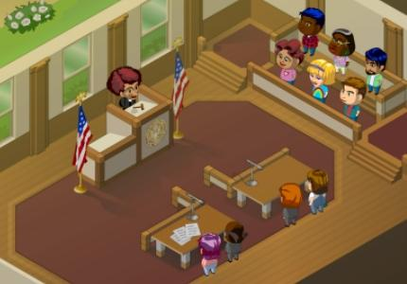

Webquest Link(s):
Bill of Rights Game
Question(s):
Which of the rights you saw is the most important to you? Explain why. (If you can’t remember the rights, this Bill of Rights Chart might help.)

More Changes
The Bill of Rights was ratified in 1791. (How long ago was that?) You can probably guess that more changes have been made to the Constitution since then.
Follow the link to see them. (Here’s that Roman Numerals Chart again. You might need it!)

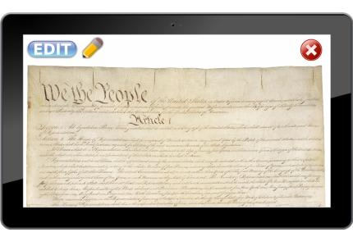

Webquest Link(s):
Guide to the Constitution
Question(s):
- How many amendments are there all together, including the ones in the Bill of Rights?
- What does the 13th Amendment do?
- What does the 26th Amendment do?

Which Group are YOU In?
Now you know all about the Constitution. Right? Well… Maybe not everything. But you don’t have to know too much about the Constitution to know more about our government than some people do. Believe it or not, there’s a large group of Americans who can’t name the three branches of government!
Follow the link to find out the sad truth.

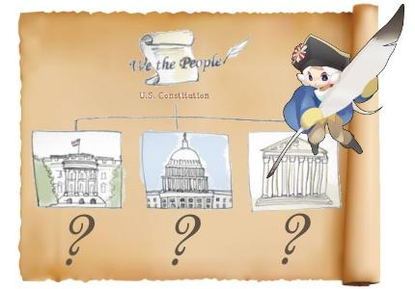

Webquest Link(s):
Three Branches Survey Results
Question(s):
- What percent of Americans can name all three branches? Give the actual percentage--don't just say "nearly."
- What percent can’t name any? (The actual number, please.)
- Can YOU name all three? (No peeking!)

