2. What Is Economics All About?

When most people think about economics, they see numbers, graphs, and equations. Indeed, in this book, you will encounter a fair number of graphs and the occasional equation. But that is not what economics is all about. In their popular book Freakonomics, economist Steven Levitt and journalist Stephen Dubner argue that economics "is about stripping a layer or two from the surface of modern life and seeing what is happening underneath." This is what Adam Smith did in 1776 and what economists continue to do today.
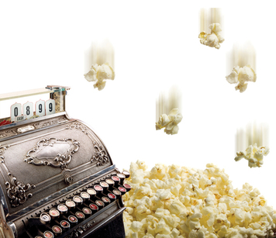

Everyday Mysteries and Economic Enigmas
When they strip away a layer from the surface of modern life, economists often uncover curious mysteries and enigmas. These economic enigmas are puzzles or riddles that might be explained through an economic analysis. For economist Steven Landsburg, finding and solving such mysteries is what economics is all about:
First, it is about observing the world with genuine curiosity and admitting that it is full of mysteries. Second, it is about trying to solve those mysteries in ways that are consistent with the general proposition that human behavior is usually designed to serve a purpose.
—Steven E. Landsburg, The Armchair Economist: Economics and Everyday Life, 1993
Some of the mysteries that Landsburg refers to are large and abstract. For example, why does an economy grow for a long time and then start to shrink? Others deal with smaller, everyday enigmas that an ordinary person might wonder about. For example, one question Landsburg pursues is, why does popcorn sold at the movies cost more than at a grocery store? Another is, why are so many products sold for $2.99 and so few for $3.00?
Not all economists think of their job as investigating economic enigmas. But most would agree that economics has a lot to do with asking questions that reveal what the Freakonomics authors call "the hidden side of everything."

How People Use Limited Resources to Satisfy Unlimited Wants
Economics has traditionally been defined as the study of how people—individually and in groups—choose to use their limited resources to satisfy their unlimited wants.This concept of economics goes back at least to the ancient Greek author Xenophon, whose book Oeconomicus described how a household should manage its resources.
A resource is anything used to produce an economic good or a service. Resources are limited, or scarce, because they exist in finite amounts. Only so many workers, minerals, machines, and other resources can be used at any given time to produce goods and services. Resources also have alternative uses. Trees, for example, can be used to build houses, to make paper, or to burn for fuel.

Despite the scarcity of resources, people's wants are unlimited. At any one moment, we may have enough of certain things to satisfy us. But we would still like more of other things. Even the wealthiest people want more—perhaps a fancier vehicle or a bigger home.
Economists divide their study of how people use their scarce resources into two main branches. Microeconomics looks at economic decision making by individuals, households, and businesses. Macroeconomics focuses on the workings of an economy as a whole.

Economists look at how individuals and whole societies try to satisfy their unlimited wants given their limited resources. This issue is so central to human existence that Alfred Marshall, an influential 19th-century economist, described economics as “a study of mankind in the ordinary business of life.”

The Science of Decision Making
Look again at the traditional definition of economics. Notice that it also involves studying how people choose to use their resources. When people cannot have everything they want, they must make choices. Some economists argue that economics is mainly about how we make these choices. They would define economics as the science of decision making.

As a consumer, you are continually making decisions. Should you buy a sandwich or a salad for lunch? If a salad, should it be lettuce or spinach? Should you top it with tomatoes, onions, or peppers? What about the dressing? These decisions may seem relatively trivial. But what about larger decisions, such as should you look for a weekend job? Or should you accept a credit card offer you got in the mail? Economists have developed ways of thinking about such choices that can lead to better decision making.

What Is and What Should Be: Positive Versus Normative Economics
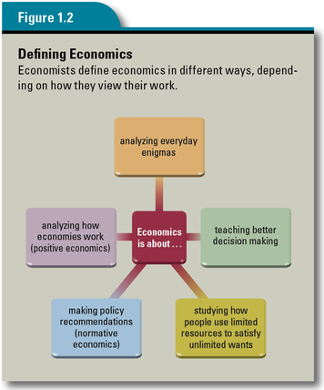

Economists spend a great deal of time describing how things are and why. But sometimes, they are also asked to offer advice on what should be done to make things better. Consider the following two questions, which a school board facing a budget crisis might ask of an economic analyst:
Question 1: What impact will increased enrollment, salary increases, and rising maintenance costs have on next year's budget?

Question 2: What actions should we take now to reduce expenses in order to balance next year's budget?

To answer the first question, the economic analyst would gather facts about the number of new classes needed to cope with rising enrollment, the salaries of school employees, maintenance costs, and other expenses. This type of analysis, which describes how things are, is known as positive economics.

To answer the second question, the economic analyst would not only gather facts but also analyze the various choices the school board has for cutting costs. Having laid out the choices and their possible impacts, the analyst would then make a recommendation to the board on where to cut costs.This type of analysis, which focuses on how things ought to be done, is known as normative economics.
Most economists are engaged in positive economics. But many others have taken on the role of policy advisers to government officials. In this role, they go beyond the objective facts to recommend actions based on what they believe to be the best way to achieve the officials' desired objectives.

