6th GRADE SOCIAL STUDIES: A WORLD CLASS TRIP! With your teacher, Miss Theresa Kuhrt

Trip Highlights (Course Description)

Travel through the Western Hemisphere on an incredible journey! That's exactly what we'll do in 6th grade social studies. We'll learn the steps necessary to explore strange new worlds and some familiar ones as well. During the year, we'll look at maps and geographic tools, study the five themes of geography, and travel to North America, South America, and Europe. While there, we'll learn about the land, history, current events, people, and culture that make this world such an interesting place. In our class, we will use the textbook, Exploring Our World – People, Places, and Cultures as our guide along with several accompanying activities: high-level questions and answers, vocabulary, tests, quizzes, group discussions, group projects, hands on activities, map activities, and research writings.

Traveling necessities (Student Supplies)
I try and provide as much as possible for my students, but there are a few things that students will need for class:
1. Writing utensils. It doesn’t matter whether it is pencil or pen (blue or black ink only)
2. A spiral notebook for notes
3. Loose-leaf paper for assignments or journal writing
4. Some type of folder – it could be a three ring binder or a small folder to keep organized
5. Crayons or colored pencils for map and poster work

Keeping in touch with those at home (Accessibility)

1. Contacts
The best way to contact me is by email, as I am a shared teacher, having classes in both the middle school and high school. Because of this, I don’t often get to hear phone messages until later.
Email: Theresa.kuhrt@hanoverhorton.org
Phone: 517-563-0102 ext. 305

2. Remind.com
Another great way to get information about any major tests and projects is to sign up for Remind.com. This involves a text message or an email being sent to your phone. To sign up for this service, you will need to text @cc8hd6 to 81010 for text messaging or for email go to rmd.at/cc8hd6 and sign up for email notifications. This will ONLY send you messages for Social Studies (other classes have other codes). Please note that I only use REMIND for major projects or tests. I do not use this for daily assignments. For that, please check the website. I also suggest setting up a daily routine where you sit down with your student and go over their planner. This will help them to get in the habit of writing down important information and staying organized, and it will help you see what they are doing daily.

3. Website
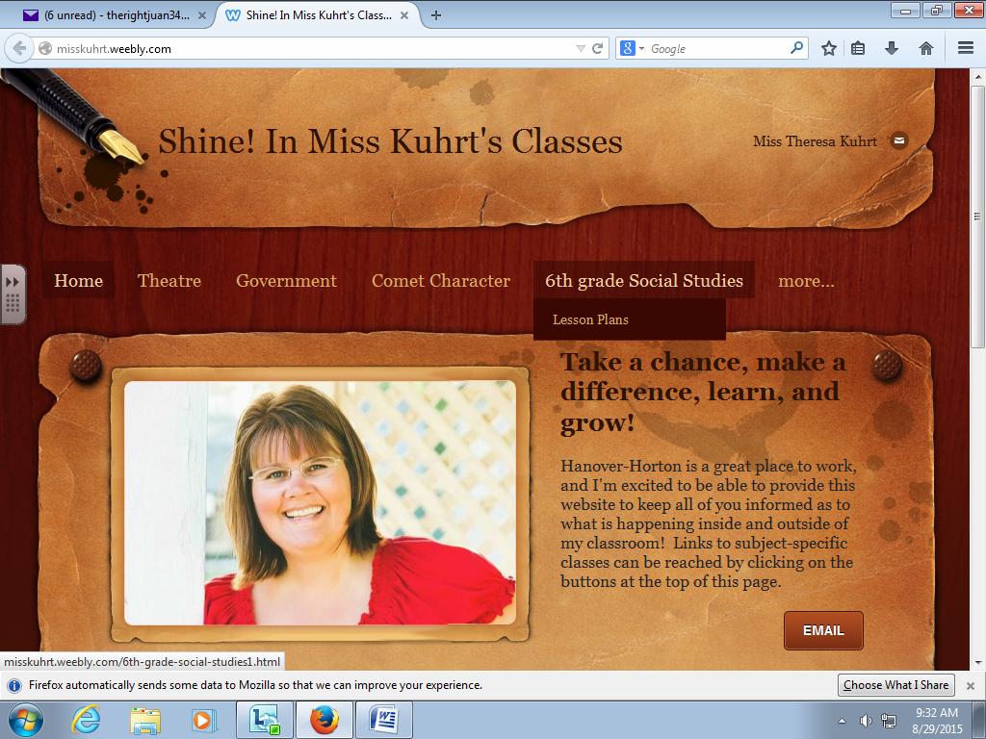
1. Go to misskuhrt.weebly.com
2. When you get to this page, hover over your class name up toward the top and you will see lesson plans. Click on the lesson plan button!
3. The lesson plans will show up for that week. While I do lesson plans in advance, and these may be posted, I find that situations in the classroom usually cause these lesson plans to vary. Therefore, I update my lesson plans daily (hopefully – sometimes life has other plans), and these updates should be made by 5:00 p.m.
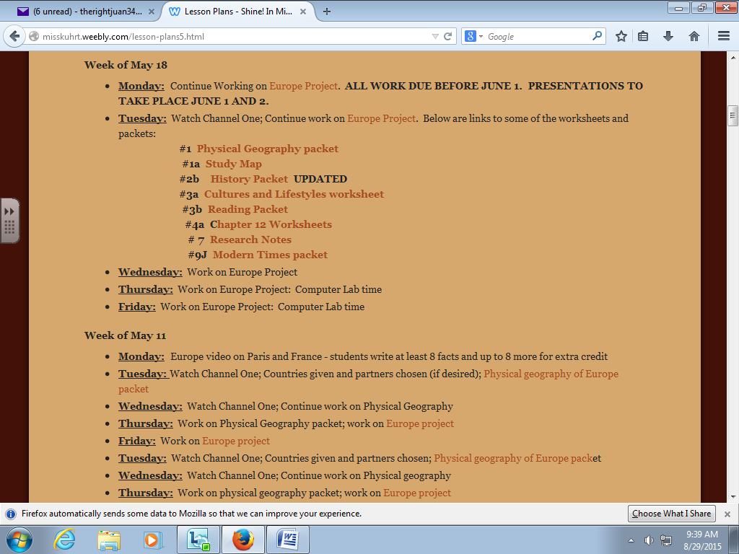
4. When you get to the lesson plan page, this is a sample of what you will see. Please note that anything that you see in a different color such as the burnt brown is a link. If you click on this, it will open up to a new page – the assignment, important notes, worksheets, or study materials. It’s important to click on these!

Add-Ons and Incidentals (Classroom wish list)
If you would like to help provide for our classroom, we can always use tissues, clipboards, hand sanitizer, extra pencils, tape, individually wrapped candy, posterboard, or white board markers

Don’t mind the Turbulence (some last words of Encouragement)
Sixth grade is a year full of changes and sometimes it can get a little bumpy. You might feel scared, overwhelmed and discouraged, and these feelings are normal. Please know that we are HERE FOR YOU to help you through all the rough spots! Don’t be afraid to come to us with your concerns. We know you can do it, and we know you can be a success.

Students will receive a complete itinerary (syllabus) on the first day of school, including information on our reward program (grading policies), emergency procedures (behavior consequences), travel guidelines (rules and expectations), and our no-show policy (attendance)

